DEVELOPMENT AND ANALYSIS OF VARIOUS DSP KERNEL BENCHMARKS ON DIFFERENT PROCESSORS

Team 10
Divya Ramachandran (UFID: 46761308)
Lalitha Mathi(UFID:29341966)
Palak Shah (UFID: 55510961)

Abstract-In this project, we have developed various DSP kernels for two platforms - Intel Xeon Phi and NVIDIA Fermi-Class GPU. The kernels selected for this purpose are Discrete Cosine Transform (DCT), Fast Fourier Transform (FFT), Infinite Impulse Response (IIR), Canny Edge Detector and Image Filters (Mean and Median Filters). These kernels are parallelized using the openMP and CUDA. The serial code for each benchmark is tested on the Xeon Phi Host and the parallel versions are tested on Xeon Phi Co-processors and NVIDIA GPUs. These parallel codes are executed and compared with the serial execution to evaluate performance of the two platforms. Various performance metrics like time taken to execute, speedup, throughput (operations per seconds) are used to compare the performance and results are presented in the form of tables and graphs.
I. Introduction
Various Kernel benchmarks contain key functions, usually obtained as a subroutine from the actual program. To best utilize a heterogeneous platform, it is often useful to use fine-grained kernels. Each kernel is enabled for the appropriate device. Because the processor units of every device are radically different, each kernels need to be written separately for the each device.[1] In this project, we develop various DSP kernels for two devices - Intel Xeon Phi and NVIDIA Fermi class GPU. These kernels are used as benchmarks evaluate the performance of these two devices.
For this project, we have developed high performance DSP benchmarks that cover a wide range of applications. Out of the kernels we chose, some of them focus on data intensive memory-operations while others stress the compute intensive system throughput. The kernels are parallelized to optimize the performance of the corresponding DSP algorithm. The kernels include some popular DSP functions like DCT, FFT, and IIR that use multi threaded high level subroutines. DCT and Image filters are used frequently in image processing applications like radar, software defined radio, lossy compressions of audio and image, image analysis like image compression and decompression, and noise filtering [2]. DCT and Image filters are used in JPEG and MPEG compressions. Canny edge detector is popular in computer vision/image processing applications. Image processing and Edge detection algorithms are known for having large size of input data and highly parallelizable steps. This property can be used to leverage the processor features and help in illustrating GPU/coprocessor features effectively. Most DSP applications are heterogeneous and fine-grained. This takes care of the problems and bottleneck caused by the PCI-express bus.
Intel Xeon Phi and NVIDIA Fermi-class GPUs have architectures that improve PCI-express data sharing by providing direct access to the memory buffers between processor and coprocessor. The memory access techniques are greatly improved by this. The above mentioned processors have various uses in the data intensive and computation intensive applications. But they are have the main limitation of bottleneck caused by the PCI-express. This bottleneck happens due to cost of communication lines and the complexity of parallelizing a long serial code during computation. To alleviate this problem, the kernels are developed to give fine grained distribution of data. The shared memory in the device architectures enables better inter-device data. Thus the kernel can directly access the CPU memory and vice versa and the subroutines parallelize the computation. On heterogeneous platforms, this gives a profound acceleration in the data-intensive and compute intensive applications by using kernels [1].
The rest of the paper is organized as follows: In section II, we describe related work in this direction. The in Section III we talk about the architecture of Intel's Xeon Phi co-processor and about the openMP APIs. In Section IV, we have talked about the architecture of NVIDIA's Fermi class GPUs and about the CUDA programming language developed at NVIDIA. In Section V, we give a brief theory about each of the benchmark and then explain in detail how it is parallelized to run on Xeon Phi and the GPUs. In Section VI, we present our results in the form of graphs and tables and analyze them in detail. Finally. in Section VII, we provide a conclusion and suggestions for future work in this direction.
II. Related Work
The main question that one asks while making a benchmark is what kind of kernels consists of a benchmark set?[3] The past 20 years have seen the emergence of a number of compute intensive benchmarks like Livermore Fortran Kernels, NAS kernels, LINPACK Benchmarks. There have also been a few synthetic benchmarks called Whetstone and Dhrystone Benchmarks. Other than these standard benchmarks, there are some application benchmarks also. These benchmarks have made use of DSP algorithms to test various applications. Some of the famous ones are SPEC, OCEAN, ADM and others. In our project, we have derived our inspiration from these benchmarks and attempted to create our own set of DSP application benchmarks that can be tested on Intel Xeon Phi and NVIDIA GPUs.
III. Intel Xeon Phi
A. Xeon Phi architecture:
The Xeon Phi series is Intel’s product line based on Intel Many Integrated Core Architecture or Intel MIC computer architecture. It inherits many features from Intel’s earlier work on Larrabee architecture. Larrabee architecture was the outcome of their research on GPGPU chip in order to develop integrated graphics accelerators. However, the MIC architecture is intended as a coprocessor for high performance computing. These processors leverage the x86 architecture and programming model.
As per the November 2013 top 500 supercomputers list published by top500.org, Tianhe-2 of China’s National University of Defense Technology, tops the list with a performance of 33.86 petaflop/s. This supercomputer employs Intel Xeon Phi coprocessors. The Xeon Phi employs a good power management strategy that makes it suitable for use in data centres.
The platform we have used is Intel 5110P.
Architecture:
The Intel Xeon Phi 5110P employs 60 cores and operates at 1.053GHz. It uses a Tri-Gate technology manufactured using 22nm process
The architecture consists of a host and coprocessors connected via a PCI Express 2.0x16 (PCIe) bus. Multiple coprocessors can communicate via this bus without needing any host intervention. They can also connect via a network card through an Ethernet or InfiniBand connection.
Each core consists of the following components:
A cache
L1 instruction cache (32KB) | 8-way caches with 64B line size
L1 data cache (32KB) | 8-way caches with 64B line size
L2 instruction + data cache (512 KB) | 8-way caches with 64B line size
There are global distributed tag directories that help in maintaining cache coherency. The tag directories maintain a Globally Owned, Locally Shared (GOLS) status. Some delay is caused due to directory status updates.
Simultaneous data cache loads and stores are possible. Cache to cache transfer of data is supported i.e. if a processor does not find the required data in its L2 cache, other L2 caches are scanned with the help of the tag directories before approaching the memory controller for data.
Translation Lookaside Buffer
64 entry second level

Memory controllers
These are symmetrically interleaved around the ring.
8 dual-channel GDDR5 | Each channel can deliver data at 5.5GT/s
Thus, a maximum bandwidth of 320GB/s can be fetched.

PCIe client logic

All these components are connected by a bidirectional, high bandwidth ring interconnect. The memory controllers and PCIe client logic act as the interface for the memory with the coprocessor and bus.
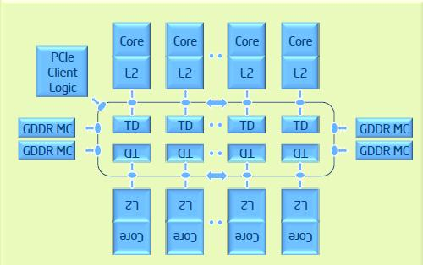
Figure1.[4] Components connected by interconnect
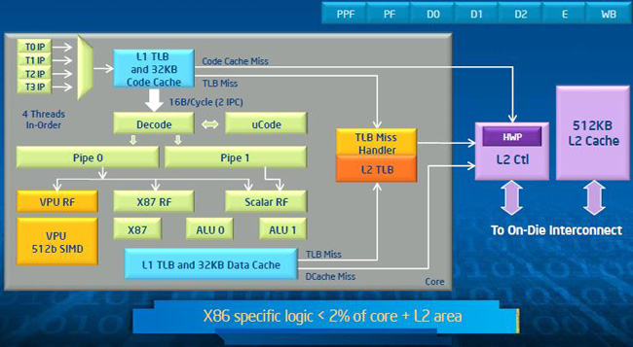
Figure2. [4] Core architecture
Interconnect:
The interconnect is composed of three independent sets of rings in each direction.
Data Block ring | 64 bytes wide; to send data blocks
Address ring | 2 rings; To send memory addresses and commands
Acknowledgement ring | 2 rings; To send cache coherence and flow control messages

The core uses a short in-order pipeline and runs 4 threads.
The coprocessor consists of a 512-bit SIMD instruction set vector processing unit (VPU). It supports fused multiply-add (FMA) instructions. Thus, it is capable of executing 16 single-precision or 8 double precision operations per cycle. With FMA, it can execute 32 single-precision or 16 double precision operations per cycle. The VPU is enhanced with a mask register that improves software pipeline efficiency by vectorizing short conditional branches, a gather and scatter unit and an Extended Math high bandwidth unit that aids in executing certain type of mathematical operations in a vector fashion.
Software support:
One of the biggest advantages of the Xeon Phi is that it does not necessitate any special programming environment. The MIC architecture runs a LINUX operating system and supports software coded in high level languages such as C, C++ and Fortran. A user can access the coprocessor through a secure shell and run individual jobs on it. Programs can be designed and run in different ways – entirely on the host, on the host and coprocessor and entirely on the coprocessor.
Optimizations:
In order to gain a good performance, the caches must be effectively utilized. If there is a possibility of restricting the data accessed by a code within its L2 cache and within all L2 caches (after L1 data cache) performance gain is high. A useful approach to program for the Xeon Phi is to allocate data in blocks to processors (cache blocking). True benefits are seen in applications that involve a lot of floating point applications. As it employs the SIMD instruction set, it is useful for applications handling large amounts of data.
Position figures and tables at the tops and bottoms of pages, when possible. Avoid placing them in the middle of columns. Figure captions should be centered below the figures; table captions should be centered above. Avoid placing figures and tables before their first mention in the text. Use the abbreviation “Fig. 1,” even at the beginning of a sentence.
Figure axis labels are often a source of confusion. Use words rather than symbols. For example, write “Magnetization,” or “Magnetization, M,” not just “M.” Put units in parentheses. Do not label axes only with units. In the example, write “Magnetization (A/m)” or “Magnetization (A ⋅ m1).” Do not label axes with a ratio of quantities and units. For example, write “Temperature (K),” not “Temperature/K.”
Multipliers can be especially confusing. Write “Magnetization (kA/m)” or “Magnetization (103 A/m).” Figure labels should be legible, about 10-point type.
B. OpenMP:
OpenMP is an API that implements parallelism using multithreading wherein a master thread, which is forked using #pragma directives into a given number of slave threads, that divides the task in between them. They all run at the same time. Based on the scheduling the threads are assigned to different processors using usage and machine load and synchronization takes place once they finish the allocated part of the task. OpenMP is mainly compiled using C++ and Fortran. We have only used C++ in our project. Intel Xeon Phi codes can be implemented in OpenMP. Even though it is not an ANSI standard, it is still used on Microsoft and there is even a GCC-OpenMP project[1]. OpenMP is used for both data parallelism and task parallelism using pragma directives and work sharing constructs.
#pragma preprocessor directives
omp_get_thread_num() | Threads that are spawned have an integer id associated with them. This directive gives the node id.  Master thread id=0
Omp_get_max_threads() | The maximum number of threads that can be employed in the given task
Omp_get_num_threads() | The number of threads that are employed for a given
pragma omp parallel | Creates other slave threads to parallelize any given program. The node at which it is instantiated is the master node.
Pragma single | Executed by only one thread with a barrier in the end.
Pragma atomic | When memory update is atomic
Pragma barrier | Each threads wait until all the other threads reach that point.
Pragma ordered | Block is executed exactly in the order of the structure.
Pragma critical | The block within the loop will be exected by only one thread. Protects shared memory.
Pragma no wait | Threads that have finished the processing can move on without waiting for other threads(no barrier)
Table1. Pragma directives
The OpenMP functions are contained in aheader file " omp.h" in C++ and is compiled in gcc with a –fopenmp command.
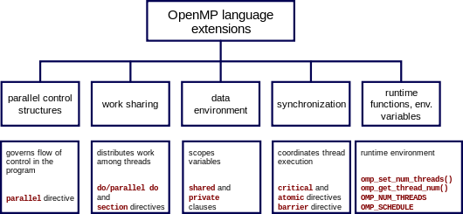
Figure3. [5] Chart of openMP constructs

Data Sharing
Shared | Data is shared by many threads within the parallel process
Private | Uninitialized Data is stored in the local memory of each thread and is private to thread
Default | User states that the default data be shared or private
First private | Same as private but initialized it
Last private | Same as private except value is updated
Reduction | Joining the threads' work.
Thread Private | Data is shared but while processing in one thread it becomes private to that thread.
Table 2. Data Sharing
Scheduling : Work sharing is done by means of scheduling. It can be static, dynamic or guided. Static scheduling is based on compiler time that divides the a large number of computations while Dynamic scheduling is based on run time to perform a small number of computations. Guided scheduling is based on the chunk size per thread.
Data copyin functions like copyin and copy private and Reduction operator are also some of the directives in openMP. Flush restores the value of memory from the register because it has been executed outside parallel part. Other user runtime routines depend upon execution in parallel region, number of processors, locks, timing etc.

IV. NVIDIA FERMI CLASS GPU
A. Fermi Class GPU architecture:
Graphics Processing Unit (GPU) is mainly used for displaying and computing large graphical data. The GPUs currently in the market have hundreds of CPU cores and each core can process up to hundreds of threads in parallel. Thus they provide excellent results in parallel processing. For this project we work on the NVIDIA Fermi Class GPUs available in the High Performance Computing Lab. The various features of NVIDIA Fermi Class GPUs are enumerated below.
The NVIDIA Fermi architecture has some very significant improvements over the older G80 versions. The Fermi Architecture has improved performance of both single as well as double precision floating point computations. It provides ECC support for protection against memory errors. It provides more shared memory and enables applications to properly use the cache hierarchy of GPUs. It provides faster read-modify-write operations and faster context switching between application programs to improve speed. Thus the Fermi architecture has increased the programmability and compute efficiency very drastically as compared to previous models.

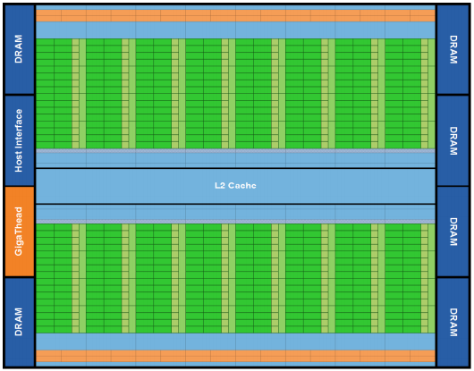
Figure 4[8]. Fermi’s 16 SM around a common L2 cache. Each SM = vertical rectangular strip that contains:
orange portion = scheduler and dispatch
green portion = execution units
light blue portions = register file and L1 cache

Some of the salient architectural features of the Fermi class GPUs are:
Third Generation Streaming Multiprocessor (SM)
- A Fermi class GPU has 16 SMs with 32 CUDA cores per SM, making that 512 CUDA cores per GPU. Each SM exhibits 4 times the performance of traditional Shared Memory multiprocessors
- Each CUDA processor has an ALU unit and Floating Point Unit. These units are fully pipelined and show 8 times the performance shown by GT200.
- In our project we mostly concentrate in the integer ALU. This function is optimized to support 32-bit and extended 64-bit precision operations effectively. The various instructions supported are : Boolean, shift, move, compare, convert, bit-field extract, bit-reverse insert, and population count
- Fermi class Functional units are designed for double precision. It can supportup to 16 double precision fused multiply-add operations per SM, per clock, Thus providing a drastic improvement over previous GPU architecture
- Each SM supports 16 times faster Load/Stores by having 16 Load /Store units allowing memory operations to be carried out 16 threads at a time
- The various units of Fermi Class GPUs are arranged as shown in Figure 2.

Improved Memory Subsystem
- The GPU has The GPU supports a 384-bit memory interface, with six 64-bit memory partitions. Thus it supports 6 GB of GDDR5 DRAM memory.
- NVIDIA Parallel DataCacheTM hierarchy provides a configurable partitioning of shared memory and L1 cache and a unified L2 Cache
- As mentioned above, it is the first GPU with ECC memory support
- It provides perfectly atomic performance for memory operations as well
- The memory access instructions of Fermi GPUs support transition to 64-bit addressing mode. Also, the memory access instructions provides better performance through Predication

Bus and Scheduler:
- NVIDIA GigaThreadTM Scheduler Engine provides 10 times faster application context switching
- It executes kernels concurrently and instructions are executed out of order
- Dual Warp Scheduler can schedule and dispatch functions simultaneously from two entirely separate warps. Each wrap consists of 32 Threads.
- Fermi can give good hardware performance using this elegant dual issue feature.
- The GPU is connected to the Host Interface using a PCI-express bus.

Second Generation Parallel Thread Execution ISA
- NVIDIA Fermi provides full C++ support using a unified Address Space. It also provides optimised support for OpenCL and DirectCompute.
- The ISA for C, C++, Fortran and other compiler targets is independent of the machine on which it is running.

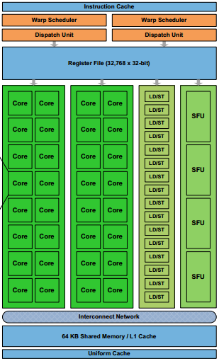
Figure 5.[8] Fermi class GPU architecture
B. CUDA
To Implement a banchmark on GPU, we need standardized graphics API. The standardized graphics APIs available for this like OpenGL and directX. Compute Unified Device Architecture (CUDA), developed at NVIDIA, can also be used to write benchmarks on an NVIDIA GPU. CUDA provides optimum results on NVIDIA GPU by leveraging the architecture GPUs to execute programs written in C, C++ or Fortran and openGL.
CUDA executes codes in form of kernels that are run across many parallel threads. These threads are organized in form of Thread blocks by the compiler. The blocks can also be programmatically included by the programmer. Each thread has a threadID, program counter, registers, input and output results. Each block of thread is made up of many parallel threads that cooperate using barrier synchronization and shared memory. Each thread block holds a its own shared memory. This shared memory is useful for communicating between threads by sharing data and result in parallel algorithms. A grid consists of an array of thread blocks that execute on the same kernel. It reads to and writes from a global memory and helps to synchronize between department kernel calls. Grids of thread blocks have a Global Memory space where they share their results after performing a kernel-wide synchronization. The CUDA memory architecture is depicted in Figure3.
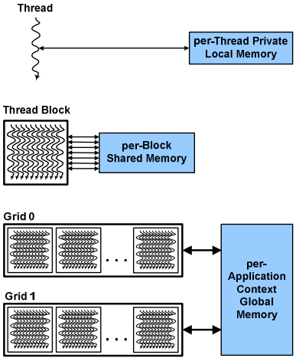
Figure6.[8] Memory Structure of Threads in CUDA.
CUDA Hardware Support:
The memory hierarchy of threads in CUDA maps to a memory hierarchy of processors on the GPU. Multiple kernel grids are executed by a GPU, multiple thread blocks are executed by a streaming multiprocessor (SM) and multiple threads are executed by CUDA cores and other execution units in the SM. Threads are executed by the SM in groups of 32 threads called a warp. Performance of a code can be improved greatly by having threads in a warp execute the same code path and access memory in addresses that are located nearby.

CUDA Libraries: [https://developer.nvidia.com/gpu-accelerated-libraries]
CUDA Provides many libraries that we have leveraged in our project whenever possible.
Some of the many libraries provided by CUDA are described in Table 1.

Name | Functionality
CuBLAS | NVIDIA CUDA BLAS Library (cuBLAS) is a GPU-accelerated version of the complete standard BLAS library. This library delivers about 6times to 17times faster performance than the latest MKL BLAS libraries.
CuFFT | NVIDIA CUDA Fast Fourier Transform Library (cuFFT) provides a set of functions to develop FFT. This library is used instead of writing an FFT code to get best performance
NPP | NVIDIA Performance Primitives is a GPU accelerated library developed by NVIDIA. It defines many image processing and signal processing primitives
MAGMA | Provides a huge collection of linear algebra routines. Designed for next gen heterogeneous GPU-based architectures. Supports current LAPACK and BLAS standards.
CuSPARSE | NVIDIA CUDA Sparse (cuSPARSE) Matric library provides a collection of basic linear algebra subroutines used for sparse matrices. This library delivers over 8times performance boost.
CuRAND | The CUDA Random Number Generation library performs high random number generation accelerated by GPU (RNG). It gives speeds that are over 8times faster than CPU only code.
CUDA Math Library | It provides highly accurate collection of standard mathematical functions, proven by industry. This library provids very high performance, especially on NVIDIA GPUs.
NVIDIA VIDEO CODEC SDK | This library provides a complete set of NVIDIA video codec tools that we can use to accelerate our video performance. this library includes the NVENC H.264 hardware encoding API as well as NVCUVID CUDA decoding API.
OpenCV | OpenCV is the leading open source library for computer vision, image processing and machine learning. It now features GPU acceleration for real-time operation.
Geometry Performance Primitive GPP | GPP is a computational geometry engine that is optimized for GPU acceleration, and can be used in advanced Graphical Information Systems (GIS), Electronic Design Automation (EDA), computer vision, and motion planning solutions.
Table3. List of CUDA Libraries provided by NVIDIA[8]

CUDA Syntax:
For this project, we have made use of the CuFFT and NPP libraries. In order to use CUDA, we must allocate memory on the GPU accelerators for our input and output variables. We use the cudaMalloc() function for that. The inputs are copied from host to Accelerator using the cudaMemcpy() and setting the flag as cudaMemcpyHostToDevice and the output is copied from Device to host in the same way by setting the flag as cudaMemcpyDeviceToHost. CudaThreadSynchronize() is used to bring the threads to a barrier synchronization. At the end of the code all memory on the host as well as accelerator device is freed using cudaFree. The other functions are different for different benchmarks depending on the library used.
V. DSP Kernel Benchmarks
A. Discrete Cosine Transform (DCT):
Discrete cosine transform (DCT) transforms data into a frequency domain where data is referred to by set of coefficients. The advantage of DCT is that data may be concentrated in low frequency components based on the mutual relation between data. In DCT, a waveform is represented by sum of cosine functions of different frequencies, Consider a few discrete points(say n) on the waveform in set A
. DCT can be DCT-I, DCT-II, DCT-III, DCT-IV based on normalization factor but DCT-II is ‘the DCT’ which we have implemented.

For a one dimensional DCT(DCT-II), the coefficients are given by
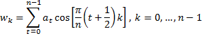[4]

We scale these by a factor of and to make them orthogonal (i.e., their dot product, where denotes the length or magnitude of is zero).

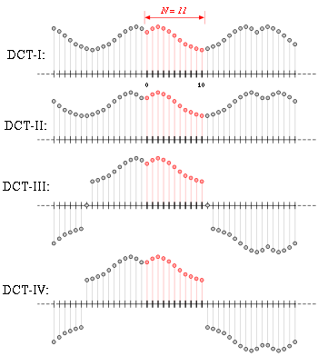
Figure7. [9] DCT Waveforms

Method of optimization:
The DCT code takes a 2D matrix as input. In order to parallelize the DCT algorithm, we used two methods. In the first method, we divided the input among threads, one row at a time leading to a coarse grained data distribution. This method, though correct, was not the most optimized one. Another, better method was to divide the input data as one element per thread. The thread was allowed to continue operating ahead without waiting to be synchronized with others. This was accomplished in openMP using #pragma with nowait. This method, which gave finer granularity in data distribution, was more optimal and gave better results.
For Xeon Phi:
As mentioned above, in Xeon Phi, we achieved fine grained data distribution. The scheduling of threads was done statically, so that each thread would perform equal number of operations. By making use of nowait directive, we ensured that no thread is idle at anytime. These techniques helped us to leverage the Xeon Phi Architecture which in turn gave good speedup.
For GPU:
For the GPU, data was divided as blocks in order for each processor to be able to work on a block of data.
B. Infinite Impulse Response (IIR) Filter:
In this project, we designed a second order parallel IIR digital filter kernels have been implemented with Xeon Phi and GTX260 GPU. IIR filters results have been compared on both the processors and a baseline code. IIR filters are causal that is they have a recursive nature due to dependency on previously computed output samples. This dependency problem has to be considered in developing a parallel algorithm for the kernel, In particular individual computation of the particular solutions with homogeneous solutions has to be implemented in IIR filter. Comparing to CPU based implementation experimental results show speed improvement of 3 to 40 times for IIR filter kernels. Recursive filters have a dependency problem on previous outputs . Hence we parallelize only after the execution of the block without dependency . This reduces the dependency time. We implement it on Nvidia GTX 260 which has 194 cores and Xeon Phi with 60 cores.
A k th order filter can be modeled as
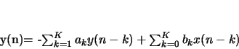
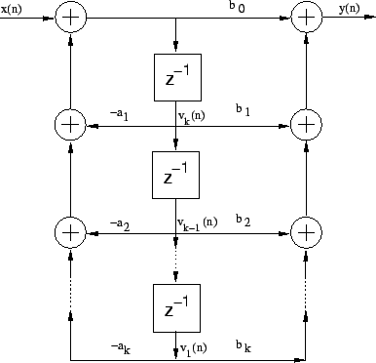 Fig-8. Direct form II realization of a general IIR filter[2]

This work has implemented recursive second order IIR filters on both XeonPhi with openMP and on GPU with CUDA. This can be modeled as
y(n) + a1 y(n-1)+a2y(n-2)= b0x(n)+b1x(n-1)
Method of optimization:
From the above equation it is evident from the figure that the current output is dependent on current input values and previous output values This dependence results in an inherently sequential part of the code. Although dependency time can be reduced by dividing the filter into blocks with and without the dependency, we still need to synchronize the blocks at the end to acquire a complete solution.
For Xeon Phi:
The part of the code without dependency is based on initial values. Hence, it can be computed in parallel. This is used to implement a parallel IIR filter in OpenMP and run it on Intel Xeon Phi processor.
For GPU:
For the GPU we map the dependent blocks with M threads with N input blocks inside it that have to be run sequentially.[3]. The threads have to be synchronized after they finish the sequential execution while individual threads run in parallel. Once it is synchronized, the execution process continues. After this we finally obtain all results and sum it up. This requires a global shared memory. Hence after synchronization we can transfer the contents of the return values to global memory.
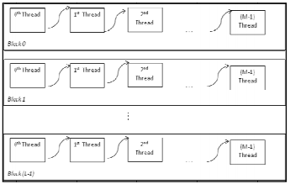
Figure 9. [9] Propagating the parallel Solution

In order to implement recursive filters like IIR filter, either we have to eliminate data dependencies first to avoid need for synchronization because synchronization is costly or bear synchronization cost overhead. This can be reduced by increasing thread level parallelism. Data dependencies in the IIR are due to the inherent sequential nature of the recursive filter. IIR involves many computations. Filter stability is another concern for an IIR recursive filter.
C. Fast Fourier Transform (FFT):
We introduce the one dimensional FFT algorithm as a kernel benchmark in our project. We canr construct FFT algorithms for different sizes by utilizing the recursive property of FFTs. In this algorithm, we use 2 FFT functions each of size N/2 that can be further divided into more FFTs recursively. After applying each such recursive relation, we get a computation which is popularly referred to as a Butterfly.

FFT can be computed from DFTs using Radix-2 method. In this method,the DFT of a vector of size N can be rewritten as a sum of two smaller DFTs, each of size N/2, operating on the odd and even elements of the vector (Fig 1). If N is a power of 2, then DFT is transformed from size N to log2N while performance increases to (O(N log2N)) and complexity reduces to O(NlogN). This is known as the Danielson-Lancsoz Lemma [G. C. Danielson and C. Lanczos] and is called Fast Fourier Transform, FFT [6].

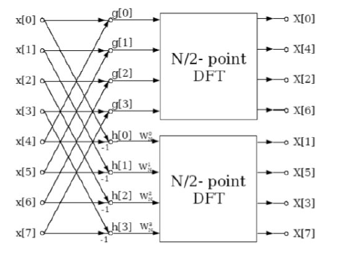

Figure 10.[10] Recursive FFT Butterfly Function

Method of optimization:
The FFT code takes a dimensions of a 2D matrix as input i.e. X and Y are inputs. The input matrix is initialized inside the code and converted into imaginary numbers using a function defined in the code. In order to get an FFT, we use recursion on a DFT algorithm. This algorithm is O(NlogN). I openMP, we parallelize the serial FFT code by using various openMP directives. In CUDA, we leverage the CuFFT library provided by NVIDIA. Since the CuFFT library makes optimal use of GPU architecture, we get really good results on the GPU.
For Xeon Phi:
In Xeon Phi, we studied the FFT code written by Wesley Petersen and modified by John Burkardt and add our ow code for testing performace. In this code, data is distributed among threads in fine grained manner. The code needs values from previous calculations as well, hence there are multiple memory structures used to store the old data. This code uses up a lot of memory and gives average results because of the dependencies on previous values.
For GPU:
For the GPU, we leveraged the CuFFT library provided by NVIDIA. Input matrix is initialized on the host machine and sent to the device machine using cudaMemCpy(). A plan for carrying out FFT is created and Actuall FFT is calculated using the cuFFTExecR2C() to perform a real to complex FFT. The complex output is returned to Host machine again using cudaMemCpy(). The time is calculated using timer.h code provided by Udacity.
D. Image Filters (Mean and Median):
The discrete convolution operation is defined as:
where is the original image, is the transformed (or filtered image), is the kernel to be applied to the image, and are the coordinates of the pixels[9]. In image filtering, convolution is applied to the pixels of a local window. Output pixel is centered at that location, and only the pixels within the considered window are used when calculating the value of that output pixel. Here the image processing function is the weighted average of the pixels lying inside the window considered.
Convolution is the function of how the input signal (shown as the u array) is modified with respect to the kernel (shown as the H array) and is given by output signal (shown as v array), the elements of which are given by the sum of the products formed by multiplying all the elements of the kernel with appropriate elements of the input signal. The convolution operation is used extensively in DSP, biomedical engineering, and graphics for smoothing, filtering, and image analyses [6]. A loop is used for the filter which is reflected onto the output by means of a nested loop. Fourier transform of the convolution kernel can be applied to see which frequencies will be minimized (amplitude <1), maximized (amplitude >1) or remain same (amplitude =1). When maximum amplitude value of one, all the frequencies are independent of each other. At this stage filtering is done to achieve necessary image processing.

Method of optimization:
In an image filter code, each pixel is operated upon. It has dependency on its neighbouring pixels. For both filters – median and mean, a block size of 3x3 has been selected so that to compute every output pixel, the pixel value and the values of its 8 surrounding neighbours is taken into account.
For Xeon Phi:
For the Xeon Phi, data was divided such that single pixel computations were divided amongst threads. The operations were carried out in stages.
For GPU:
For the GPU, data was divided as blocks in order for each processor to be able to work on a block of data.

E. Canny Edge Dectector:
The fundamental logic behind edge detection is to measure the intensity differences across adjacent pixels. If the intensity difference exceeds a certain value, the pixels are marked as an edge. The Canny edge detector is known to be an optimal edge detector.
It involves the following steps:
A Gaussian filter is run across the image. This removes noise and also controls how much detailing appears on the image. Width of mask used affects the sensitivity to noise i.e. if the width is higher, it is less sensitive to noise, but at the expense of losing finer details. However, localization error increases.
An edge operator is applied to the resultant image. As a result, intensity differences across edges that are found are further processed as follows. Blurred edges are converted to sharp edges by suppressing everything but local maxima. Pixels that are not part of any edge are marked as 0. Two threshold values are used by Canny operator. Different methods may be used to select threshold values. Pixels across which intensity differences are higher than the threshold value are marked as strong and final edges. Pixels with intensity differences lower than the lower threshold value are not marked as non-edges. Those that lie between both thresholds use particular criteria- those pixels connected to a marked edge are marked as edges and the rest are marked as non-edges. The challenge of this problem is to complete the processing in real time by leveraging the high processing capabilities provided by GPU/coprocessor architectures.
Method of optimization:
The Canny operation involves a number of steps. Each step can be parallelized.
For Xeon Phi:
For the Xeon Phi, every operation was divided amongst threads such that they would operate in a fine grained manner. Each thread would operate on each pixel computation.
For GPU:
For the GPU, data was divided as blocks in order for each processor to be able to work on a block of data.
VI. Results
The benchmarks were developed and run on the two platforms. We used the highest level optimization "-O3" provied by gcc. The result for parallel execution were obtained by running the code many times on the co-processor. This ensured that the values of initial set up time and latency due to cache misses became negligible. The serial code was run on the Intel Xeon Phi Host CPU. Various parameters such as input size and number of threads were varied and corresponding results were obtained. We analyzed these results against that of the serial code execution to get performance metrics like speedup, Operations per second, throughput, etc. These results are presented here in the form of graphs and tables. We have measured how the distribution takes place among threads while measuring per thread statistics, but we have reported results only for multiple threads. The order of benchmarks is same as that in the previous section :
A. Discrete Cosine Transform (DCT):
OpenMP on Xeon Phi :
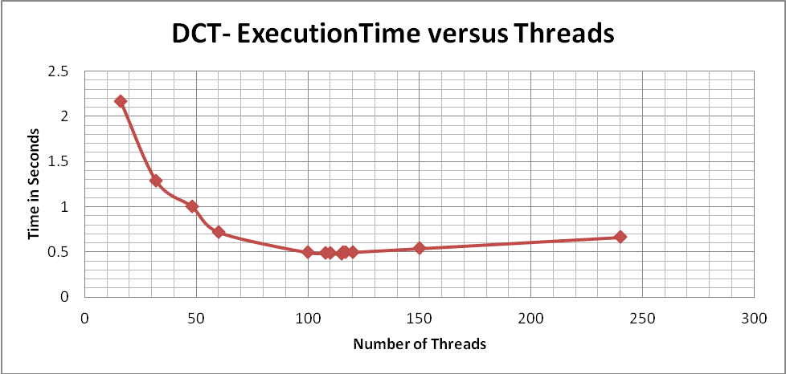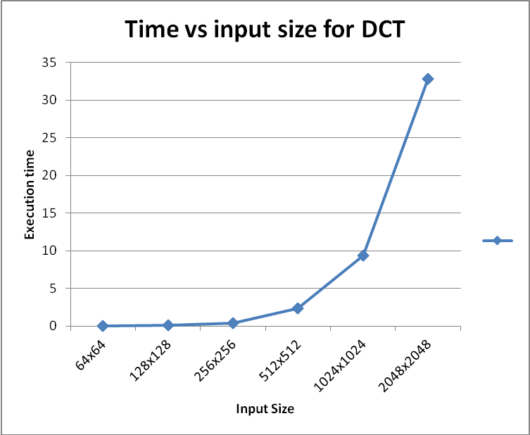
CUDA on Fermi Class GPU:
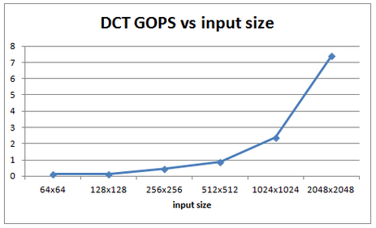
B. Infinite Impulse Response (IIR) Filter:
OpenMP on Xeon Phi :
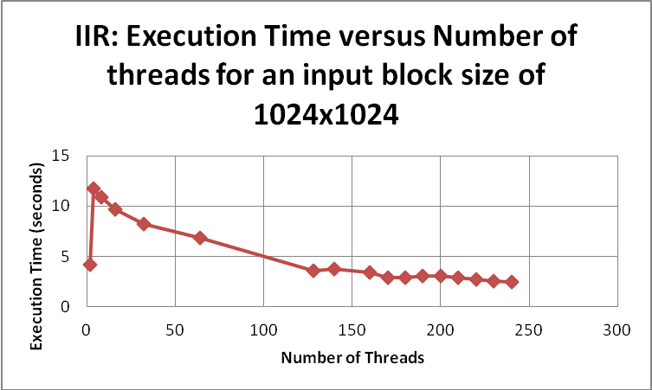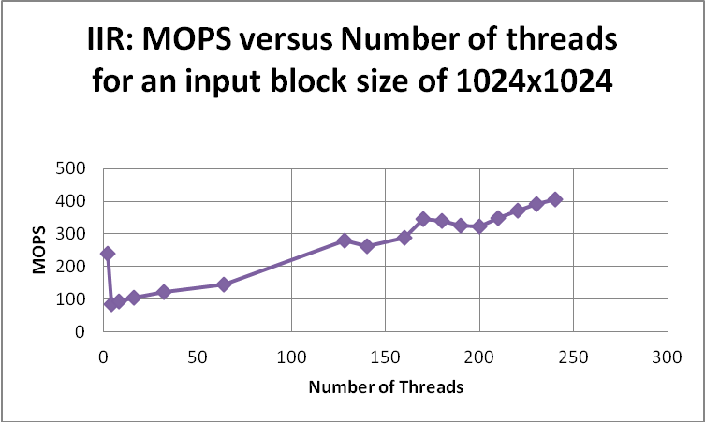
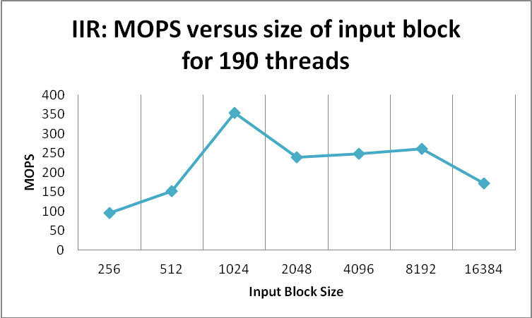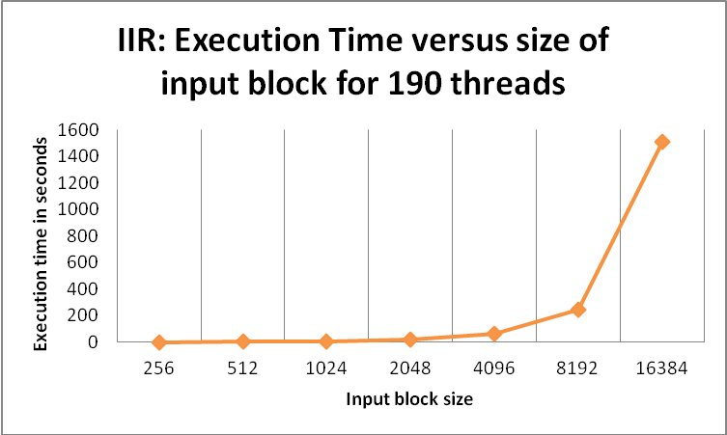
CUDA on Fermi Class GPU:
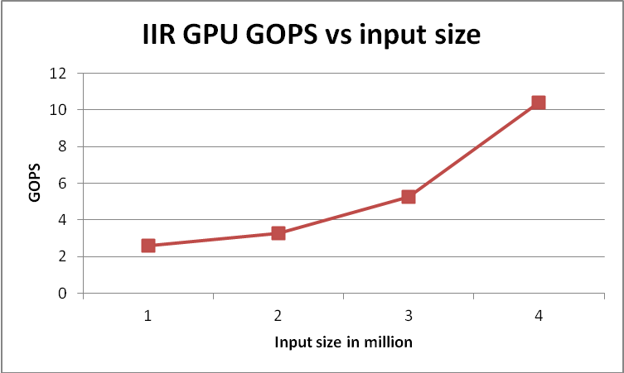
C. Fast Fourier Transform (FFT):
OpenMP on Xeon Phi :
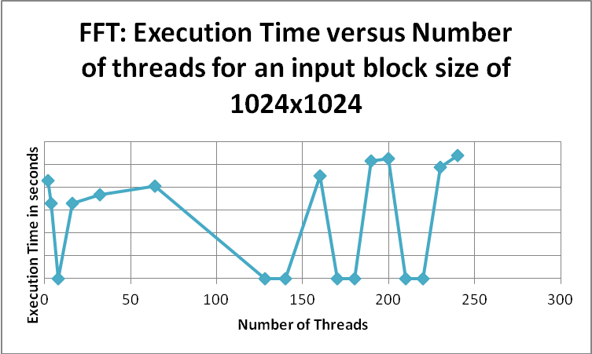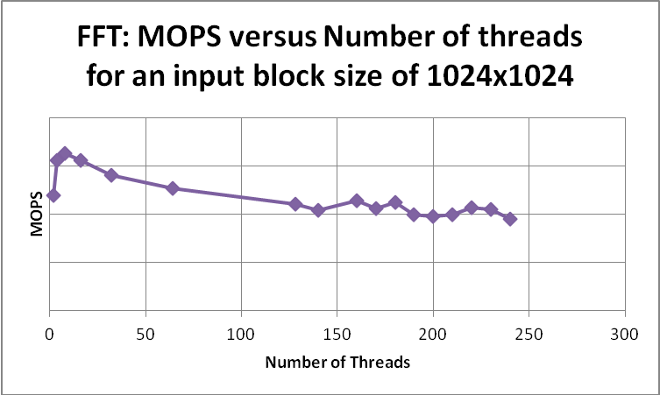
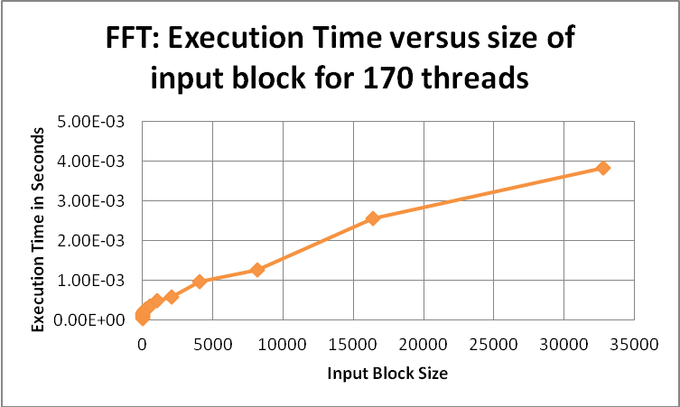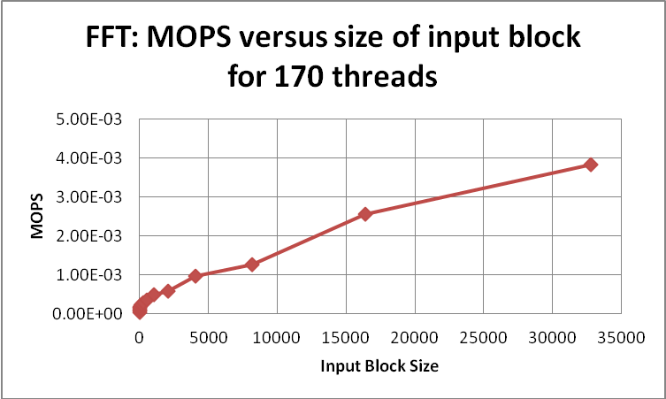
CUDA on Fermi Class GPU:
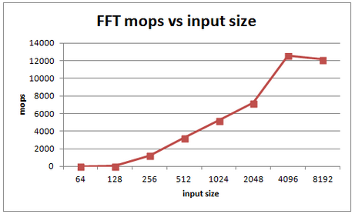
D. Image Filters (Mean and Median):
OpenMP on Xeon Phi :
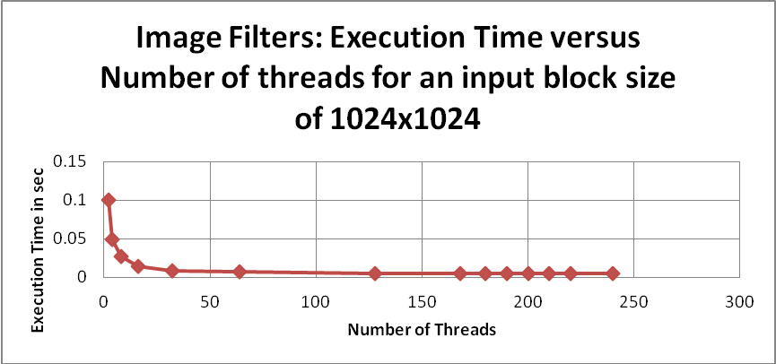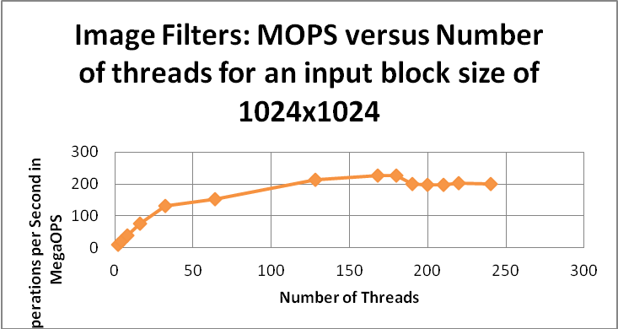
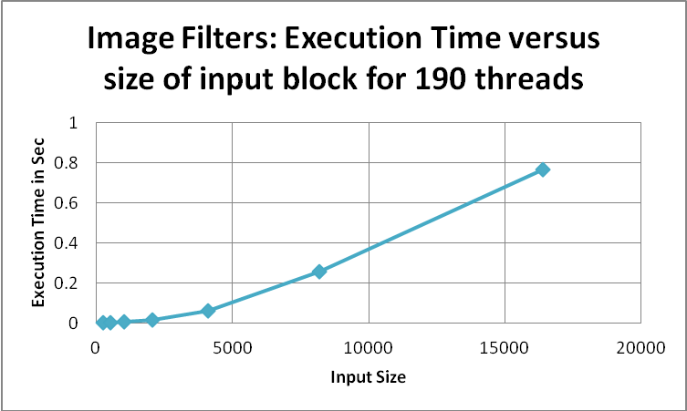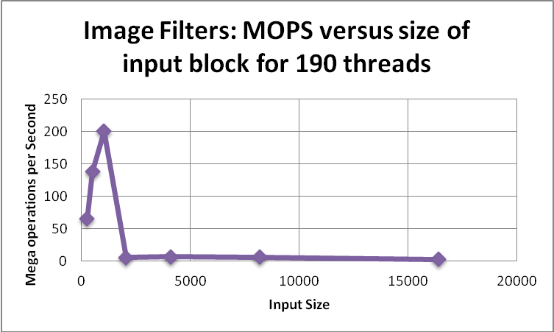

CUDA on Fermi Class GPU:
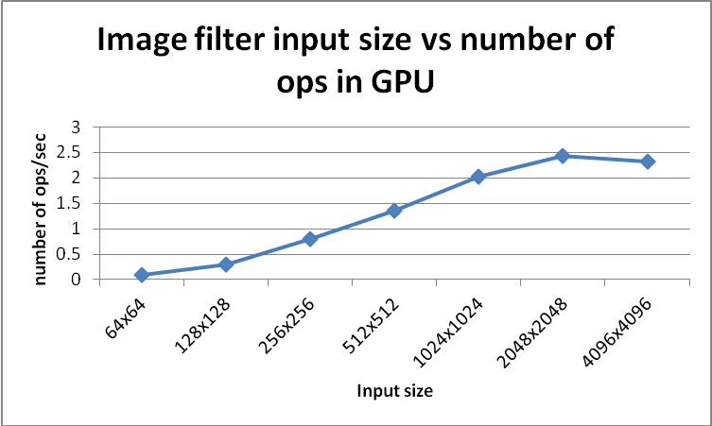

E. Canny Edge Dectector:
OpenMP on Xeon Phi :
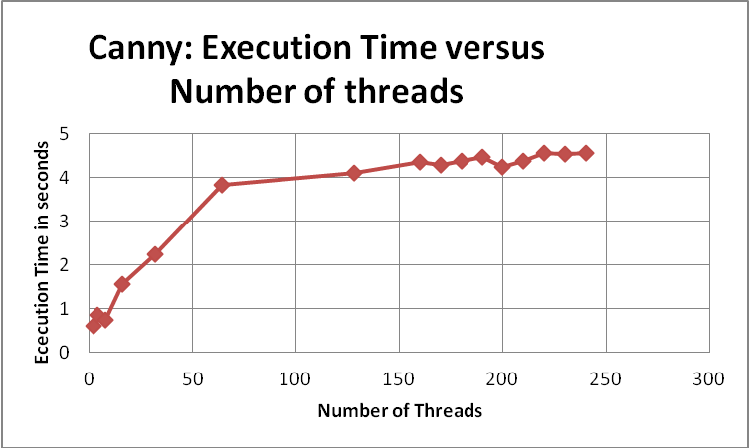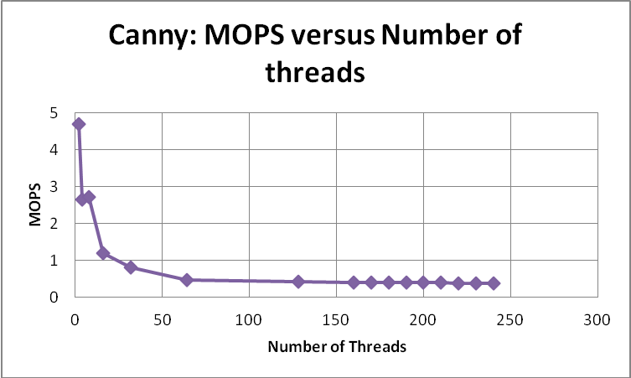
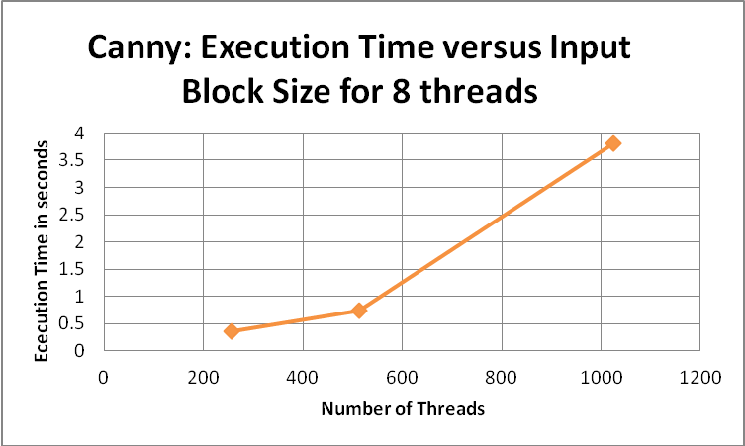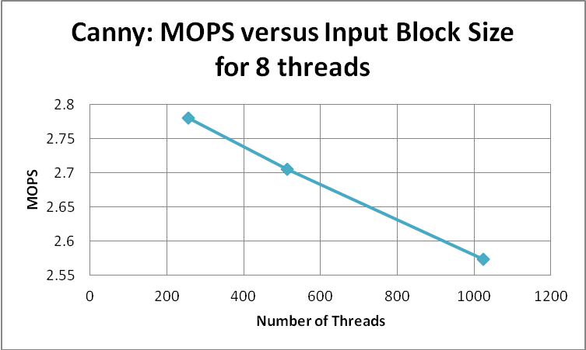
CUDA on Fermi Class GPU:

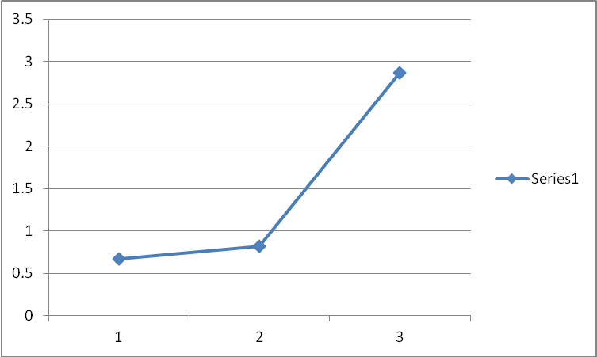

F. Analysis Of Results:
All the openMP results show some common trends. At a fixed input size, the execution time decreases as the number of threads increase. The value of execution time gains a lowest value at around 170-190 threads. Hence, we have taken 190 threads as fixed while evaluating the performance of Time and Operations per second against increasing input size. As we increase the input size, the execution time initially decreases, but after a certain point it increases again. This may be because the Xeon Phi cache is getting full thereby causing more and more cache misses.
It is also observed that the MOPs vs Threads/Input size curve attains a peak when the Execution Time curve attains its lowest value. This is consistent with our expectations.
By looking at the graphs and tables, we have calculated secondary performance matrics such as speedup and throughput from primary matrics obtained by running the codes on Intel Xeon Phi:
Benchmark Kernel | Speedup (Maximum) as compared to serial baseline | Throughput (Highest)
DCT | 41.02 (190 Threads) | ~330 Mega OPS
IIR | 1.467 (190 threads) | ~250 Mega OPS
FFT | 0.136 (180 threads) | ~425 Mega OPS
Image Filters | 45.04 (190 threads) | ~200 Mega OPS
Canny Filter | 0.5 (8 threads) | ~2.7 Mega OPS
Table 4. Secondary Performance Metrics

It was observed that the speedup in DCT and Image filters was significant, but the speedup achieved by IIR and Canny Filters is very low and that obtained by FFT is negative. This could be explained by the fact that computation of all three requires values from previous calculations. Due to such data dependencies, these algorithms cannot be completely parallelized.
The values of throughput observed in each of the Kernels is quite high. But we get these values only at very large values of Inputs.
VII. Conclusion ad Future work
In this project we have successfully compared the performance of two different platforms, namely Intel Xeon Phi and NVIDIA Fermi Class GPU. It was found that while some benchmarks like DCT and Image Filters perform well, others like FFT, IIR and Canny Filter perform badly on both the platforms. For the kernels that performed well, we were able to optimize them in order to get the maximum performance.
It was observed, that in general, GPU's perform better than the Xeon Phi. This is largely due to the fact that we used data level parallelism in our benchmarks, a trait that is implicit in the GPUs. Also, from our experience, we determined that leveraging the libraries gave better results than if we had written the entire code ourselves.
Future work may include developing more industrially relevant DSP benchmarks like Box Filters, IDCT, IFFT, Gaussian Filters, etc and make a more complete set of Benchmarks.
Acknowledgment
We would like to thank Dr. Alan George for authorizing us to use the resources of CHREC and HPC labs. This course and this project has been a great learning experience for us. We would also like to thank Bryant Lam for his constant guidance throughout the project. Finally, we would like to thank Stefan Creciun and Andy Miluzzi for their valuable inputs which helped us understand the architectures better.
References
[1] Performance characterization of data-intensive kernels on AMDFusion architectures by Kenneth Lee, Heshan Lin, Wu-chun Feng (2012), DOI 10.1007/s00450-012-0209-1.
[2] Segmentation algorithms using Cell processor, GPGPU architecture and SIMD techniques by Daniel Lélis Baggio, Fernando Fernandes Neto, Thomás Dias, Einstein do Nascimento Jr., Mauro Eidi Vilela Assano, Celso Hirata, Instituto Tecnológico de Aeronáutica – Brazil.
[3] Hannes Pfneiszl, Gabriele Kotsis, Benchmarking Parallel Processor Systems : A Survey
[4] https://software.intel.com/en-us/articles/intel-xeon-phi-coprocessor-codename-knights-corner
[5] http://en.wikipedia.org/wiki/OpenMP
[6] http://www.emt.tugraz.at/publications/diplomarbeiten/da_hoebenreich/node21.html
[7] Digital Signal Processing Filtering with GPU by Sajid Anwar, Wonyong Sung, School of Electrical Engineering, Seoul National University, Gwanak-gu, Seoul 151-744 Korea
[8] Whitepaper : NVIDIA’s Next Generation CUDATM Compute Architecture: FERMI
[9] A Characterization of High Performance DSP Kernels on the TRIPS Architecture by Kevin B. Bush , Mark Gebhart, Doug Burger, Stephen W. Keckler, Computer Architecture and Technology Laboratory,
Department of Computer Sciences, The University of Texas at Austin.
[10] Three Dimensional Fast Fourier Transform CUDA Implementation by Kumar Aatish, Boyan Zhang, Department of Computer Science and Engineering, University of California, San Diego, University of California, CSE260 Project Report, 2012

[11] R. C. Gonzalez and R. E. Woods, Digital Image Processing, 3rd ed., Prentice Hall, New Jersey 2008.
[12] http://demonstrations.wolfram.com/ImageKernelsAndConvolutionLinearFiltering/
[13] Discrete Cosine Transform, Nuno Vasconcelos, UCSD
http://www.svcl.ucsd.edu/courses/ece161c/handouts/DCT.pdf
[14] A Computational Approach to Edge Detection by John Canny, IEEE Transactions on Pattern Analysis and Machine Intelligence, Vol. PAMI-8, NO. 6, November 1986.
[15]Parallelization Strategies of the Canny Edge Detector for Multi-core CPUs and Many-core GPUs by Taieb Lamine Ben Cheikh, Giovanni Beltrame, Gabriela Nicolescu and Farida Cheriet, Ecole Polytechnique de Montreal, IEEE(2012) .
[16]Image Processing on the GPU: Implementing the Canny Edge Detection Algorithm by Yuko Roodt Highquest, Willem Visser , Willem A. Clarke, University of Johannesburg
[17] Canny Edge Detection on NVIDIA CUDA by Yuancheng “Mike” Luo and Ramani Duraiswami, University of Maryland, College Park, IEEE(2008).

